1. Create and execute a macro (show a button), to sum of “Sales” where the “attractiveness” rating is more than 5.
   1. Do it by recording a Macro.

**Answer:**

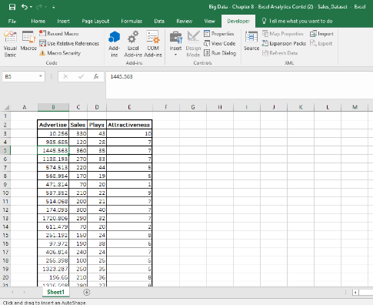

The system gets hanged, when I try to record Macros. Screen shot below. I have done the summation with the condition mentioned above

Step 1

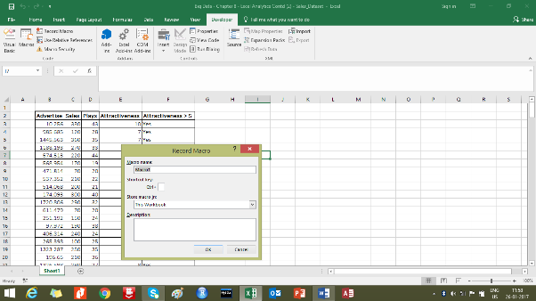

Step 2 – Getting hanged

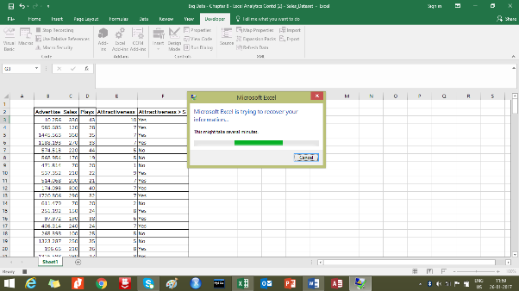

Sum of “Sales” where the “attractiveness” rating is more than 5 – 34,830

* 1. Try it using writing a VBA code in Macro.

**Answer:**

Use <http://www.excel-easy.com/vba.html> for reference to write VBA script.

System getting hanged

* 1. Protect the Workbook and save version and upload as a first part of assignment

**Answer:**

**Step 1:**

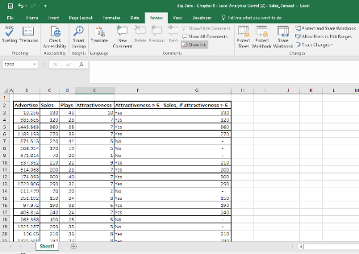

**Step 2:**

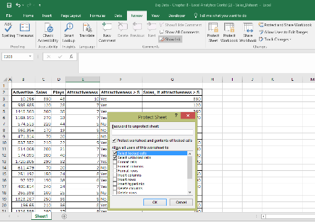

**Step 3:**

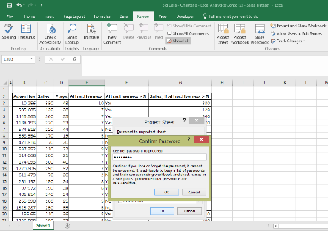

**Step 4:**

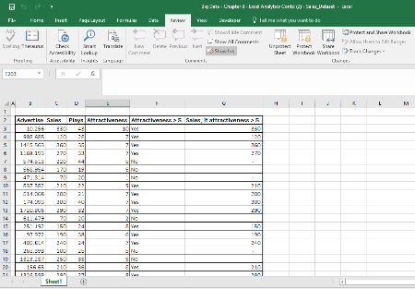

**Step 5:**

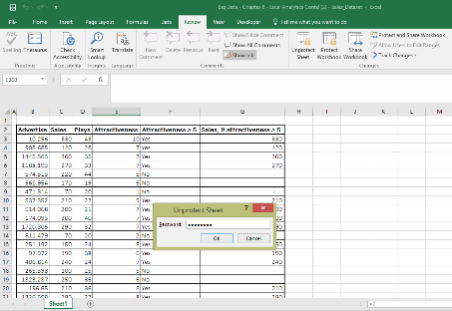

* 1. Share the protected workbook, by giving edit access and implement track change. Upload this workbook as second part of your assignment.

**Answer:**

**Step 1:**

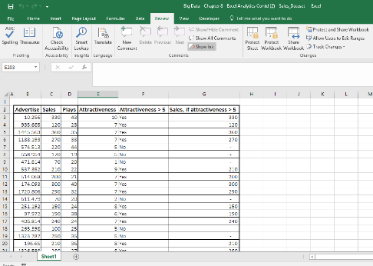

**Step 2:**

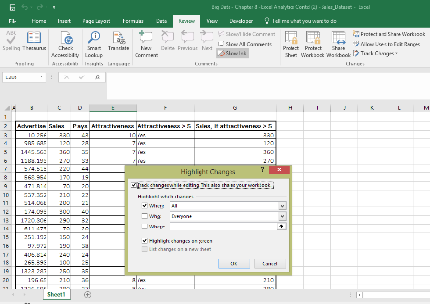

**Step 3:**

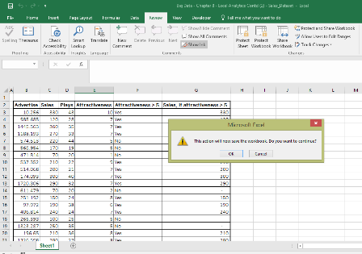

**Step 4:**

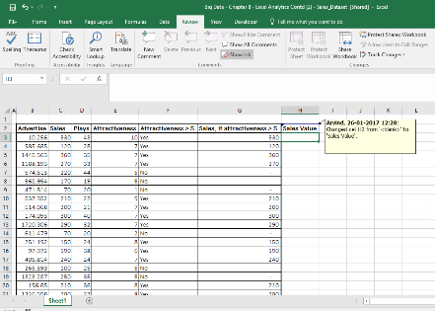

**Step 5:**

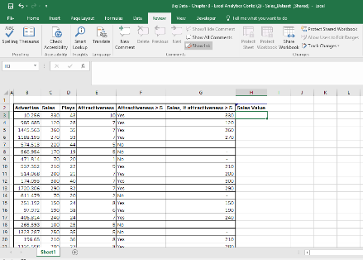

**Step 6:**

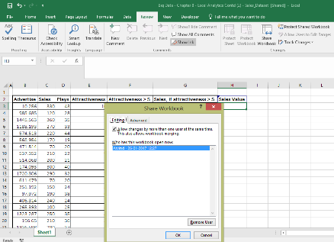

**Step 7:**

